Grove - OLED Display 0.96"
(Redirected from Grove - OLED Display 128*64)

Contents
[show]

Introduction
LED 128×64 Display module is an OLED monochrome 128×64dot matrix display module with Grove 4pin I2C Interface.Comparing to LCD, OLED screens are way more competitive, which has a number of advantages such as high brightness, self-emission, high contrast ratio, slim / thin outline, wide viewing angle, wide temperature range, and low power consumption. It has bigger screen so that it can display more contents than the OLED 96×96.
Model:OLE35046P
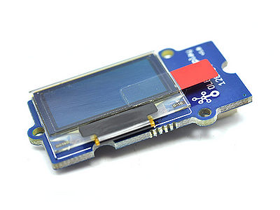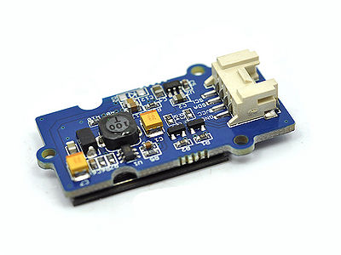

Features
- Grove compatible interface
- Communicate Mode:I2C
- Low power consumption
- Display Color: White
- Wide range of operating temperature:-20℃~70℃

Cautions
Please notice: heavy impact or stress on the OLED will cause the breakdown of screen..

Specifications
Items | Min | Norm | Max | Unit
Power Voltage (VCC) | 3.3 | 5.0 | 5.5 | V
Driver IC | SSD1308Z |  |  | -
Display Color | White |  |  | -
Dot Matrix | 128×64 |  |  | -
Panel Size | 26.7(W)×19.26(H) |  |  | mm
Active Area | 21.74(W)×11.175 (H) |  |  | mm
Dot Pitch | 0.17(W)×0.175 (H) |  |  | mm
Dot Size | 0.15(W)×0.15 (H) |  |  | mm
Wide range of operating temperature | -20~70 |  |  | ℃

Usage
The OLED128*64 uses all the pins of SSD1308 chip, the default original point is on the top left corner. You can also change the original point by adjusting the program and in order to display your desired patterns. For more details, please consult File:SSD1308_1.0.pdf and File:LY190-128064.pdf.
Here we demonstrate how to display "Seeedstudio" on the screen.
- Plug the Grove - OLED Display 128*64 onto the I2C port on Grove - Base Shield, and then plug the Base Shield onto Arduino;
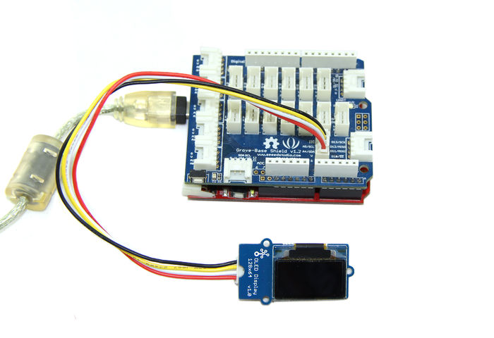
- Download the library File:OLED_Display128X64 Library;
- Unzip it into the libraries file of Arduino IDE by the path: ..\arduino-1.0\libraries.
- Open the code directly by the path: File -> Example ->OLED_Display12864->OLED_Bitmap_Inverse_Display.

#include <Wire.h>
#include <SeeedOLED.h>
#include <avr/pgmspace.h>

static unsigned char SeeedLogo[] PROGMEM ={
0x00, 0x00, 0x00, 0x00, 0x00, 0x00, 0x00, 0x00, 0x80, 0x00, 0x00, 0x00, 0x00, 0x00, 0x00, 0x80,
0x00, 0x00, 0x00, 0x00, 0x00, 0x00, 0x00, 0x00, 0x00, 0x00, 0x00, 0x00, 0x00, 0x00, 0x00, 0x00,
0x00, 0x00, 0x00, 0x00, 0x00, 0x00, 0x00, 0x00, 0x00, 0x00, 0x00, 0x00, 0x00, 0x00, 0x00, 0x00,
0x00, 0x00, 0x00, 0x00, 0x00, 0x00, 0x00, 0x00, 0x00, 0x00, 0x00, 0x00, 0x00, 0x00, 0x00, 0x00,
0x00, 0x00, 0x00, 0x00, 0x00, 0x00, 0x00, 0x00, 0x00, 0x00, 0x00, 0x00, 0x00, 0x00, 0x00, 0x00,
0x00, 0x00, 0x00, 0x00, 0x00, 0x00, 0x00, 0x00, 0x00, 0x00, 0x00, 0x00, 0x00, 0x00, 0x00, 0x00,
0x00, 0x00, 0x00, 0x00, 0x00, 0x00, 0x00, 0x00, 0x00, 0x00, 0x00, 0x00, 0x00, 0x00, 0x00, 0x00,
0x00, 0x00, 0x00, 0x00, 0x00, 0x00, 0x00, 0x00, 0x00, 0x00, 0x00, 0x00, 0x00, 0x00, 0x00, 0x00,
0x60, 0xf0, 0xc0, 0x00, 0x00, 0x00, 0xfc, 0xff, 0x87, 0x00, 0x00, 0x00, 0x00, 0x00, 0x00, 0x03,
0xff, 0xfc, 0x00, 0x00, 0x00, 0x80, 0xf0, 0x20, 0x00, 0x00, 0x80, 0xc0, 0xc0, 0x60, 0xe0, 0xc0,
0xc0, 0x00, 0x00, 0x00, 0xc0, 0xc0, 0xc0, 0x60, 0xe0, 0xc0, 0xc0, 0x80, 0x00, 0x00, 0x80, 0xc0,
0xc0, 0xe0, 0x60, 0xc0, 0xc0, 0x80, 0x00, 0x00, 0x00, 0xc0, 0xc0, 0xc0, 0x60, 0xe0, 0xc0, 0xc0,
0x80, 0x00, 0x00, 0x80, 0xc0, 0xc0, 0xe0, 0xe0, 0xc0, 0xc0, 0xf8, 0xf8, 0x00, 0x00, 0x00, 0x00,
0x00, 0xc0, 0xc0, 0xe0, 0x60, 0xc0, 0xc0, 0x80, 0x00, 0xc0, 0xf0, 0xf0, 0xf0, 0xc0, 0x00, 0xc0,
0xc0, 0x00, 0x00, 0x00, 0x00, 0xc0, 0xc0, 0x00, 0x00, 0x80, 0xc0, 0xc0, 0xe0, 0xe0, 0xc0, 0xc0,
0xf8, 0xf8, 0x00, 0xd8, 0xd8, 0x00, 0x00, 0x80, 0xc0, 0xc0, 0xe0, 0x60, 0xc0, 0xc0, 0x80, 0x00,
0x00, 0x03, 0x0f, 0x1e, 0x3c, 0x70, 0xe3, 0xcf, 0x9f, 0x30, 0x00, 0x00, 0x00, 0x00, 0x70, 0xbf,
0xcf, 0xe3, 0x70, 0x78, 0x3e, 0x0f, 0x03, 0x00, 0x00, 0x00, 0x33, 0x77, 0x66, 0x66, 0x66, 0x6c,
0x7d, 0x18, 0x00, 0x1f, 0x3f, 0x76, 0x66, 0x66, 0x66, 0x76, 0x37, 0x07, 0x00, 0x0f, 0x3f, 0x7f,
0x66, 0x66, 0x66, 0x66, 0x77, 0x27, 0x07, 0x00, 0x1f, 0x3f, 0x76, 0x66, 0x66, 0x66, 0x76, 0x37,
0x07, 0x00, 0x0f, 0x3f, 0x71, 0x60, 0x60, 0x60, 0x60, 0x31, 0x7f, 0x7f, 0x00, 0x00, 0x00, 0x00,
0x11, 0x37, 0x67, 0x66, 0x66, 0x6c, 0x7d, 0x38, 0x00, 0x00, 0x3f, 0x7f, 0x3f, 0x00, 0x00, 0x1f,
0x3f, 0x70, 0x60, 0x60, 0x70, 0x7f, 0x7f, 0x00, 0x0f, 0x3f, 0x71, 0x60, 0x60, 0x60, 0x60, 0x31,
0x7f, 0x7f, 0x00, 0x7f, 0x7f, 0x00, 0x06, 0x1f, 0x3b, 0x60, 0x60, 0x60, 0x60, 0x71, 0x3f, 0x1f,
0x00, 0x00, 0x00, 0x00, 0x00, 0x00, 0x00, 0x00, 0x01, 0x01, 0x00, 0x00, 0x00, 0x00, 0x01, 0x01,
0x01, 0x00, 0x00, 0x00, 0x00, 0x00, 0x00, 0x00, 0x00, 0x00, 0x00, 0x00, 0x00, 0x00, 0x00, 0x00,
0x00, 0x00, 0x00, 0x00, 0x00, 0x00, 0x00, 0x00, 0x00, 0x00, 0x00, 0x00, 0x00, 0x00, 0x00, 0x00,
0x00, 0x00, 0x00, 0x00, 0x00, 0x00, 0x00, 0x00, 0x00, 0x00, 0x00, 0x00, 0x00, 0x00, 0x00, 0x00,
0x00, 0x00, 0x00, 0x00, 0x00, 0x00, 0x00, 0x00, 0x00, 0x00, 0x00, 0x00, 0x00, 0x00, 0x00, 0x00,
0x00, 0x00, 0x00, 0x00, 0x00, 0x00, 0x00, 0x00, 0x00, 0x00, 0x00, 0x00, 0x00, 0x00, 0x00, 0x00,
0x00, 0x00, 0x00, 0x00, 0x00, 0x00, 0x00, 0x00, 0x00, 0x00, 0x00, 0x00, 0x00, 0x00, 0x00, 0x00,
0x00, 0x00, 0x00, 0x00, 0x00, 0x00, 0x00, 0x00, 0x00, 0x00, 0x00, 0x00, 0x00, 0x00, 0x00, 0x00,
0x00, 0x00, 0x00, 0x00, 0x00, 0x00, 0x00, 0x00, 0xf8, 0x48, 0x48, 0x48, 0xb0, 0x00, 0xc0, 0x20,
0x20, 0x20, 0xc0, 0x00, 0xc0, 0x20, 0x20, 0x20, 0xc0, 0x00, 0x40, 0xa0, 0xa0, 0xa0, 0x20, 0x00,
0x00, 0x20, 0xf0, 0x20, 0x20, 0x00, 0x00, 0x00, 0x00, 0x00, 0x00, 0x00, 0x08, 0x08, 0xf8, 0x08,
0x08, 0x00, 0xc0, 0x20, 0x20, 0x20, 0xf8, 0x00, 0xc0, 0xa0, 0xa0, 0xa0, 0xc0, 0x00, 0x20, 0xa0,
0xa0, 0xa0, 0xc0, 0x00, 0x40, 0xa0, 0xa0, 0xa0, 0x20, 0x00, 0x00, 0x00, 0x00, 0x00, 0x00, 0x00,
0x00, 0x00, 0x00, 0x00, 0x00, 0x00, 0xf8, 0x48, 0x48, 0x48, 0x08, 0x00, 0x20, 0x40, 0x80, 0x40,
0x20, 0x00, 0x00, 0x20, 0xf0, 0x20, 0x20, 0x00, 0xc0, 0xa0, 0xa0, 0xa0, 0xc0, 0x00, 0xe0, 0x00,
0x20, 0x20, 0xc0, 0x00, 0xc0, 0x20, 0x20, 0x20, 0xf8, 0x00, 0x00, 0x00, 0x00, 0x00, 0x00, 0x00,
0x00, 0x00, 0x00, 0x00, 0x00, 0x00, 0x00, 0x00, 0x03, 0x02, 0x02, 0x02, 0x01, 0x00, 0x01, 0x02,
0x02, 0x02, 0x01, 0x00, 0x01, 0x02, 0x02, 0x02, 0x01, 0x00, 0x02, 0x02, 0x02, 0x02, 0x01, 0x00,
0x00, 0x00, 0x01, 0x02, 0x02, 0x00, 0x00, 0x00, 0x00, 0x00, 0x00, 0x00, 0x02, 0x02, 0x03, 0x02,
0x02, 0x00, 0x01, 0x02, 0x02, 0x02, 0x03, 0x00, 0x01, 0x02, 0x02, 0x02, 0x00, 0x00, 0x01, 0x02,
0x02, 0x02, 0x01, 0x02, 0x02, 0x02, 0x02, 0x02, 0x01, 0x00, 0x00, 0x08, 0x06, 0x00, 0x00, 0x00,
0x00, 0x00, 0x00, 0x00, 0x00, 0x00, 0x03, 0x02, 0x02, 0x82, 0x02, 0x00, 0x02, 0x01, 0x01, 0x01,
0x02, 0x00, 0x00, 0x00, 0x01, 0x02, 0x02, 0x00, 0x01, 0x02, 0x02, 0x02, 0x00, 0x00, 0x03, 0x00,
0x00, 0x00, 0x03, 0x00, 0x01, 0x02, 0x02, 0x02, 0x03, 0x00, 0x00, 0x00, 0x00, 0x00, 0x00, 0x00,
0x00, 0x00, 0x00, 0x00, 0x00, 0x00, 0x00, 0x00, 0x00, 0x00, 0x00, 0x00, 0x00, 0x00, 0x00, 0x00,
0x00, 0x00, 0x00, 0x00, 0x00, 0x00, 0x00, 0x00, 0x00, 0x00, 0x00, 0x00, 0x00, 0x00, 0x00, 0x00,
0x00, 0x00, 0x00, 0x82, 0x8c, 0x60, 0x1c, 0x02, 0x00, 0x1c, 0x22, 0x22, 0x22, 0x1c, 0x00, 0x1e,
0x20, 0x20, 0x00, 0x3e, 0x00, 0x00, 0x3e, 0x04, 0x02, 0x02, 0x00, 0x00, 0x00, 0x00, 0x00, 0x00,
0x00, 0x00, 0x3e, 0x04, 0x02, 0x02, 0x00, 0x1c, 0x2a, 0x2a, 0x2a, 0x0c, 0x00, 0x12, 0x2a, 0x2a,
0x2a, 0x1c, 0x20, 0x1c, 0x22, 0x22, 0x22, 0x14, 0x00, 0x3f, 0x00, 0x02, 0x02, 0x3c, 0x00, 0x00,
0x00, 0x00, 0x00, 0x00, 0x00, 0x00, 0x00, 0x00, 0x00, 0x00, 0x00, 0x00, 0x00, 0x00, 0x00, 0x00,
0x00, 0x00, 0x00, 0x00, 0x00, 0x00, 0x00, 0x00, 0x00, 0x00, 0x00, 0x00, 0x00, 0x00, 0x00, 0x00,
0x00, 0x00, 0x00, 0x00, 0x00, 0x00, 0x00, 0x00, 0x00, 0x00, 0x00, 0x00, 0x00, 0x00, 0x00, 0x00,
0x00, 0x00, 0x00, 0x00, 0x00, 0x00, 0x00, 0x00, 0x00, 0x00, 0x00, 0x00, 0x00, 0x00, 0x00, 0x00,
0x00, 0x00, 0x00, 0x00, 0x00, 0x00, 0x00, 0x00, 0x00, 0x00, 0x00, 0x00, 0x00, 0x00, 0x00, 0x00,
0x00, 0x00, 0x00, 0x00, 0x00, 0x00, 0x00, 0x00, 0x00, 0x00, 0x00, 0x00, 0x00, 0x00, 0x00, 0x00,
0x00, 0x00, 0x00, 0x00, 0x00, 0x00, 0x00, 0x00, 0x00, 0x00, 0x00, 0x00, 0x00, 0x00, 0x00, 0x00,
0x00, 0x00, 0x00, 0x00, 0x00, 0x00, 0x00, 0x00, 0x00, 0x00, 0x00, 0x00, 0x00, 0x00, 0x00, 0x00,
0x00, 0x00, 0x00, 0x00, 0x00, 0x00, 0x00, 0x00, 0x00, 0x00, 0x00, 0x00, 0x00, 0x00, 0x00, 0x00,
0x00, 0x00, 0x00, 0x00, 0x00, 0x00, 0x00, 0x00, 0x00, 0x00, 0x00, 0x00, 0x00, 0x00, 0x00, 0x00
};

void setup()
{
Wire.begin();
SeeedOled.init(); //initialze SEEED OLED display
DDRB|=0x21; //digital pin 8, LED glow indicates OLED properly Connected .
PORTB |= 0x21;

SeeedOled.setInverseDisplay(); // Set Display to inverse mode
SeeedOled.clearDisplay(); // clear the screen and set start position to top left corner
SeeedOled.drawBitmap(SeeedLogo,1024); // 1024 = 128 Pixels * 64 Pixels / 8

}

void loop()
{

}

- Upload the code. Please click here if you do not know how to upload.
- You can see :
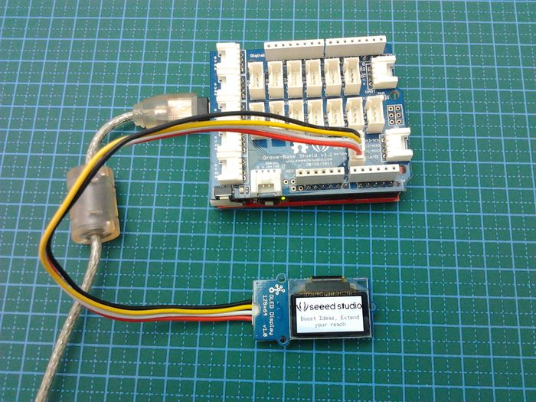
You can open other examples in the same menu bar. The key code here is the main instruction program extracted by the example, hope it can be helpful for you to understand clearly. For more details, please check the Demo code Resources linked.
Note:This module is similar to Grove - OLED Display 96*96 in its usage and some library functions, you can make an gray 128*64 image arbitrary that can be shown on OLED 128*64. Please consult the latter one's Usage part of WIKI page for detailed instructions.

Resources
- Seeed 128x64 OLED library for Arduino 1.0 and Arduino 0023
- github repository for OLED Display 128*64
- Grove-OLED128x64 Schematic.pdf
- Resources of SSD1308_1.0.pdf
- Resources of LY190-128064.pdf

Support
If you have questions or other better design ideas, welcome to discuss with us in our forum or wish to discuss.

